AARTHI .M

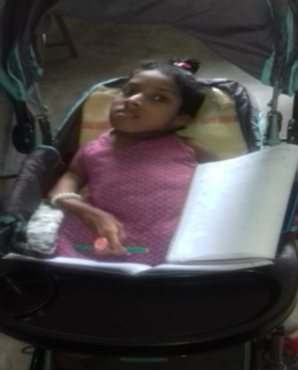

STATE : TAMILNADU

DISTRICT : COIMBATORE

BLOCK : MADUKKARAI

NAME OF THE CWSN : AARTHI .M

DOB : 10.03.2004

CLASS : 10

NAME OF THE SCHOOL : GHS KURUMBAPALAYAM

EMIS NO : 33120201107

TYPE OF DISABILITY : CEREBRAL PALASY

PERCENTAGE OF DISABILITY: 90

NATIONAL ID CARD NO : 20

EMIS : 3312020110700206

**Family Background:**

Aarthi is 16 years old student having severe CP (bed ridden) so she can’t move on her own. She is fully dependent on her parents to perform daily routine work. There are totally four members in her family, Out of them only Aarthi’s father is earning person. His name is Maarimuthu working as coolie and her mother name is Selvi. Aarthi has one elder brother who is doing final year B.E. in private institution.

**Identification:**

By her birth, up to 5 months Aarthi was a normal baby her parent’s didn’t notice any difference from her. An incident happened at sixth moth, by her neighbourhood child almost 2 years old, girl pulled aarthi legs with force this causes severe pain on her both legs. Their parents got shocked and urged to consult the doctors about her pain. Initially they couldn’t able to identify her disability. Till nine months her parents consulted several doctors for her unknown pain and finally one of the specialised GH doctor from Madurai district concluded that she had problem in bone growth and its strength. Doctor advised parents about her daughter disability like don’t force her to sit or stand often when aarthi was completed her 10th month. By 11th month she started facing severe problems like breaking bones and bed ridden things. From that day onwards her mother started taking care of Aarthi daily routines like (Eating, Bathing, etc). So spends daily life with her child.

**Academic skill:**

Aarthi started to develop reading and writing skills with the help of her mother as she is bed ridden condition makes her not able to join school. At last she joined the school at age of 8 for 1st standard in PUPS Kurumbapalayam with the help of Special educators only. They visited her home and reported the daily academic status to the respective school as she was bed ridden and no more possibility of her participation in classrooms like normal children’s. Due to rigorous hard work and eagerness in studies made her continued to studies in same school till 5th standard (half day). Inclusive Education system helped her to got admission in 6th standard in GHS Kurumbapalayam School.

She started to stay in school for the whole day with the help of stroller and her mother (by feeding her lunch). First impression is the best impression, likewise Aarthi proved her outstanding academic performance by getting 1st rank in her class starting from First Quarterly examination itself. With lot of support from Parents, Teachers and Peers, she continued her studies. She cleared NMMS Exam in 8th Standard. Her performance is always good in academics also in co-curricular activities like Elocution and Singing. It is well said that there is no completion of function without Aarthi’s participation in Kurumbapalayam School

Irrespective of her problems- Aarthi made it happen, today she was studying 10th standard .She never hesitate to write or do her projects.(Although she got problem in her wrist)

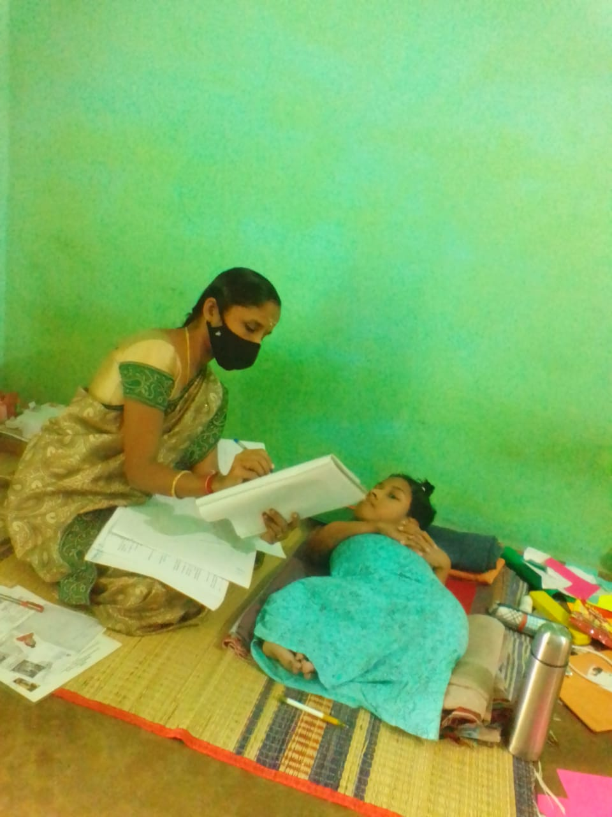

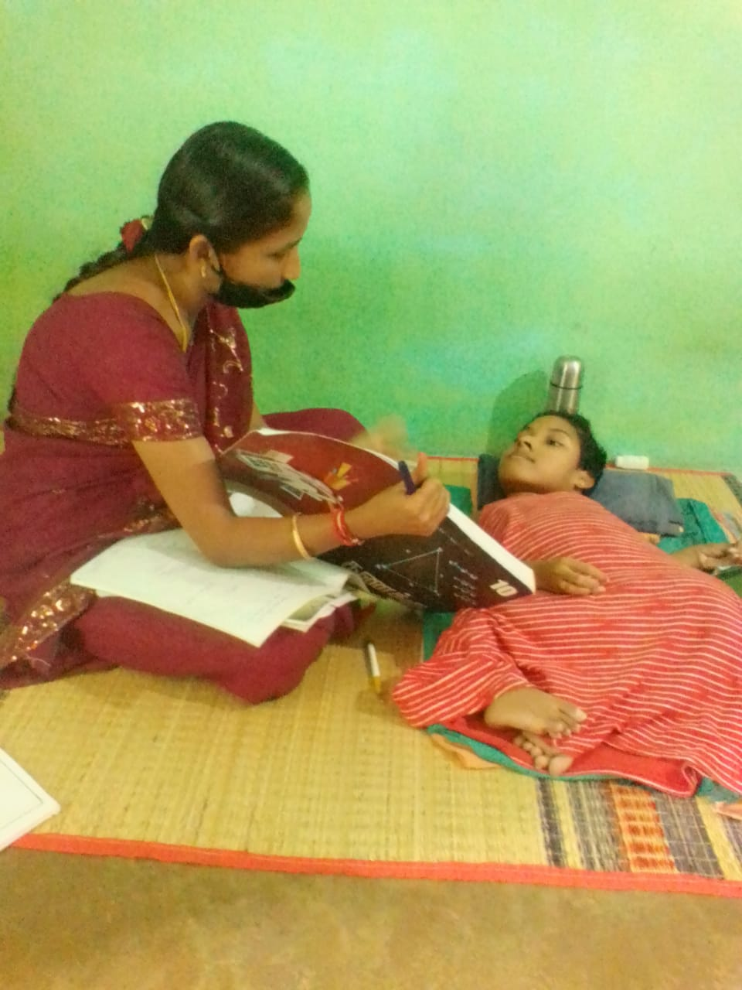

Even during Covid-19 lockdown period. Aarthi has shown interest in co-curricular activities like mini paper crafts. Though schools are closed she listened online class using ANDROID TABLET. With lot of efforts and struggle she is enjoying her studies.

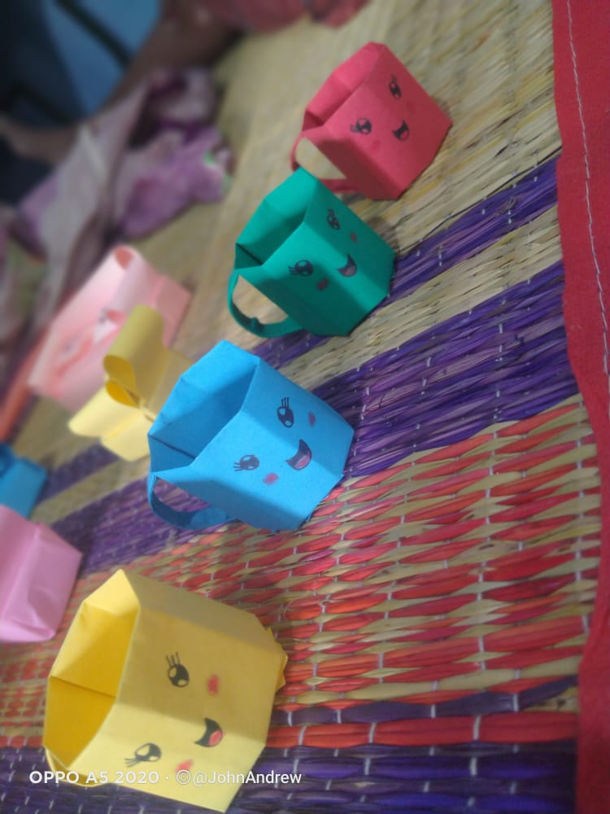

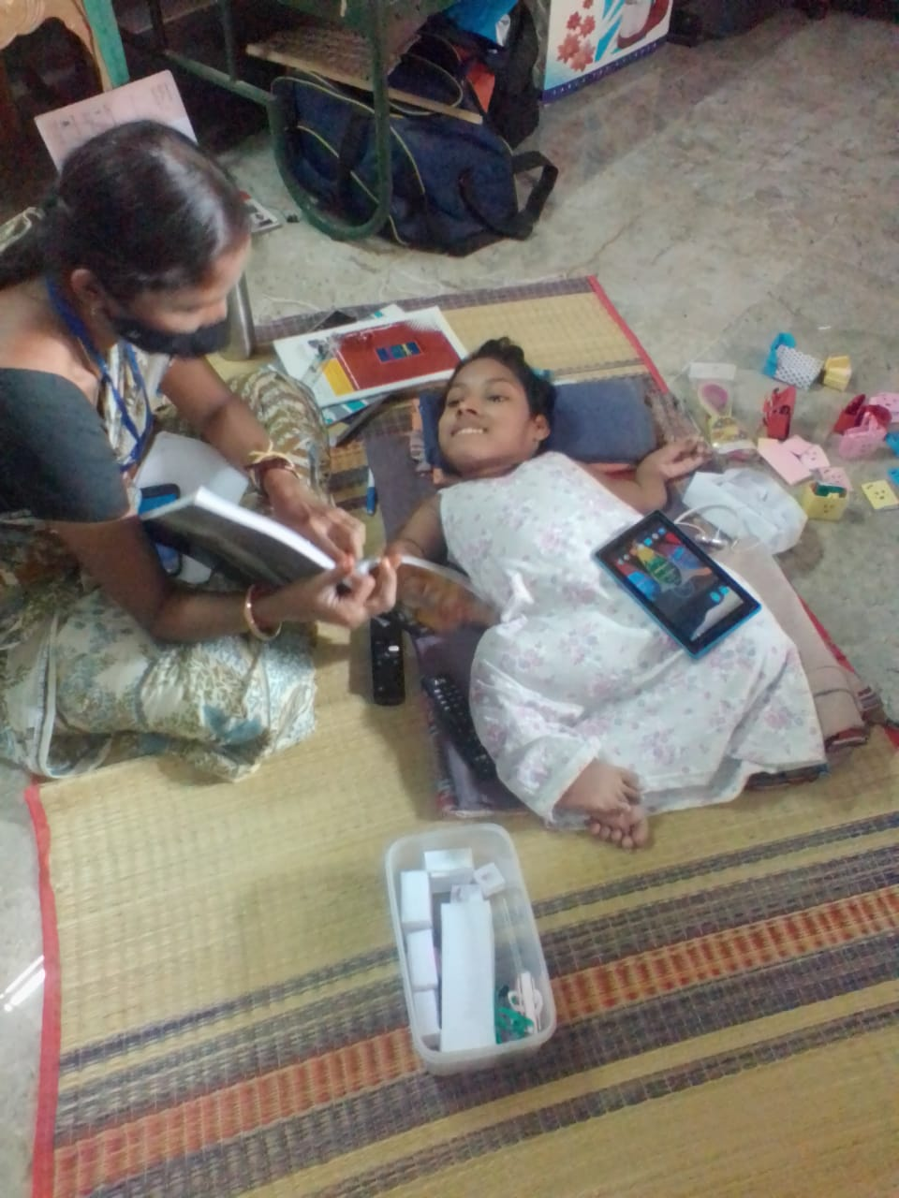

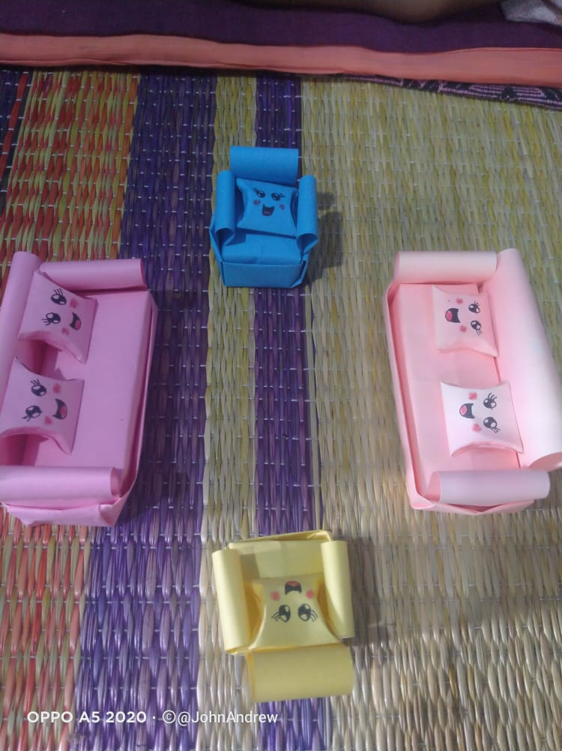

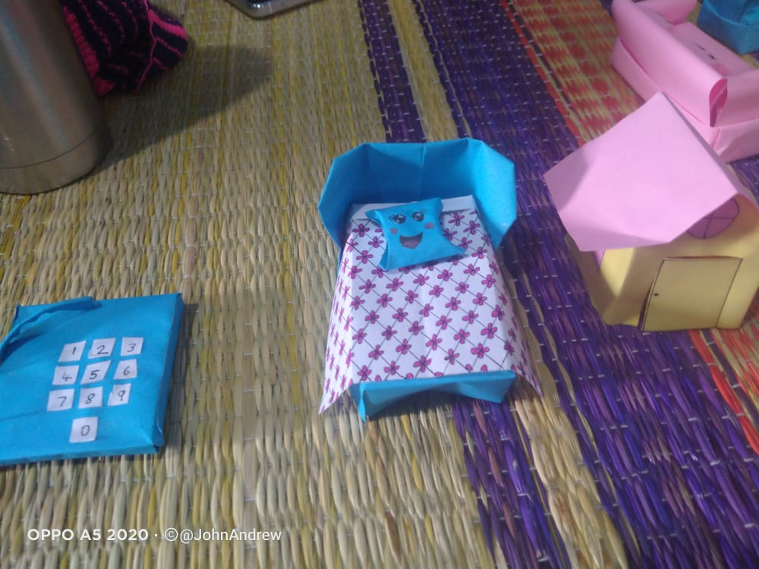

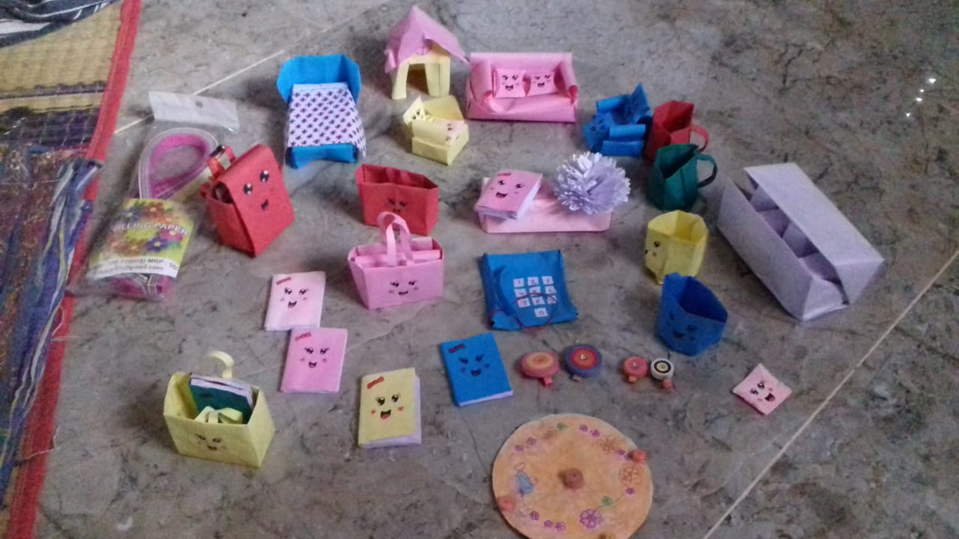

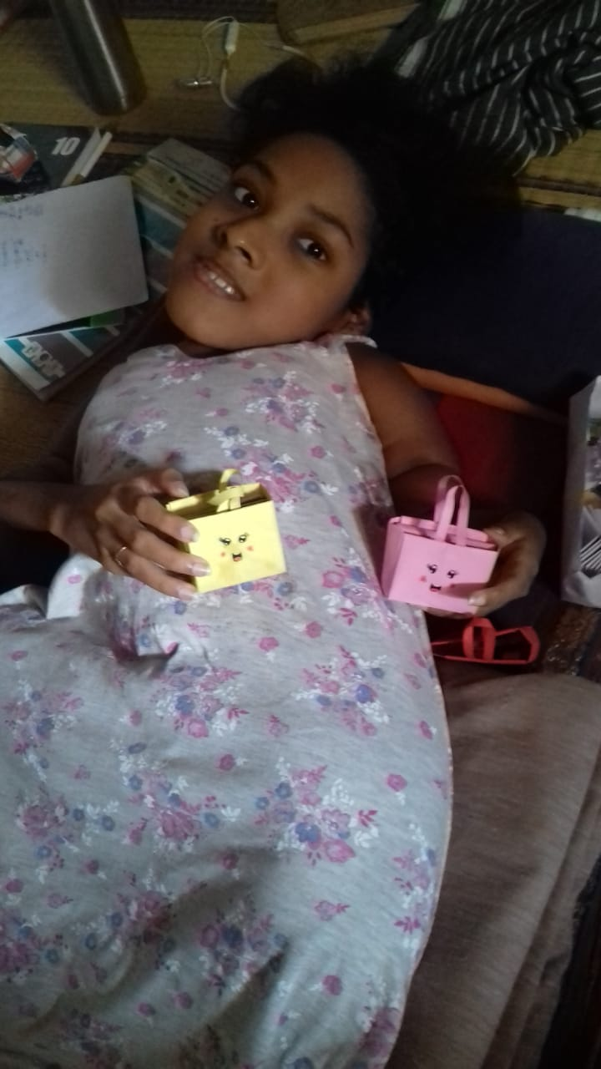

“MY ABILITY IS STRONGER THAN MY DISABILITY”

Thus Inclusive Education provides a chance for special children to spend most of their time with non special need students. It removes a barrier of special children and creates an opportunity to compete with normal children in this society.

Inclusive system provide a better quality education for all children and in development of social relationships

Inclusive Education: Acceptance of all students with hope/positive attitude

Focus on the Child –Not the disability

Talent is never disabled!